

Customer Name
Company Address
City, State, ZIP

Michaels No.: X00XXXXX
Prepared by:

Date:
Retro-Commissioning Study
Contents
Executive Summary i
1 Introduction 1
2 Building Description 3
2.1 Occupancy Patterns 3
2.2 Space Heating 3
2.3 Cooling 3
2.4 Air Handling Equipment 4
2.5 Temperature Controls 4
2.6 Humidity Controls 4
2.7 Building Pressure Control 4
2.8 Domestic Hot Water 4
2.9 Lighting 4
2.10 Compressed air 4
3 Building Energy Use and Fuel Cost Information 6
3.1 Building Energy Use and Fuel Cost Information 6
3.2 Historical Energy Use 7
3.3 End Use of Energy 8
4 Analysis Methods 9
4.1 Estimating Methodologies 9
4.2 Economic Analysis Methods 10
5 Energy Management Improvements (EMIs) 11
EMI 1 – Install New Building Automation System 12
EMI 1.1 – Implement Static Pressure Reset 16
EMI 1.2 – Implement Discharge Air Temperature Reset 17
EMI 1.3 – Standardize Space Temp Setpoints 18
EMI 1.4 – Implement Nighttime Heating Setback 19
EMI 1.5 – Schedule Exhaust Fans 20
EMI 2 – Replace Pneumatic Controls with Direct Digital Control 22
EMI 3 – Replace Remaining Fluorescent Fixtures with LEDs 24
EMI 4 – Schedule Hot Water Pump 26
EMI 5 – Install Evaporative Precooling 28
EMI 6 – Install Heat Pump Water Heater 29
EMI 7 – Install Heat Pump RTUs 31
5.1 Additional Energy Management Improvement Considered 33
5.1.1 Commission VAV Boxes and Conduct Balancing Report 33
6 Building Performance Standard Compliance 34
7 Recommendations 36
8 Next Steps 38
Appendix A Detailed System Data
Appendix B Cost Data
Appendix C Additional Supporting Data

Executive Summary
This report includes the results of a retro-commissioning (RCx) study conducted for [Customer Name] at [Customer Address]. RCx is the optimization of the facility’s energy-using systems to reduce energy and maintenance costs, and in many cases improve comfort and/or improve productivity with low-cost, high return-on-investment measures. The results of the study are summarized in the table below.
Table 1. Financial Summary Table
Measures with a combined payback of less than two years are recommended. However, if [Customer Name] chooses to implement any of the capital investment measures and they want to use any Colorado Springs Utilities incentive programs (i.e. custom rebate), they need to gain pre-approval from Colorado Springs Utilities before any equipment is purchased or installed.
The Colorado Springs Utilities RCx Program will pay 75% of the study cost directly to Michaels Energy, and Michaels Energy will invoice the remaining 25% of the study cost directly to [Customer Name] per the following billing schedule:
- 50% after completion of the on-site study and potential measures have been identified.
- 40% after the final study report is completed and presented to [Customer Name].
- 10% after measurement and verification of installed measures. If [Customer Name] chooses not to install any measures, the final 10% will be invoiced after the final study report is presented.
[Customer Name] may be eligible for performance-based incentives from Colorado Springs Utilities for implementing measures identified in the study report. To be eligible for this incentive, [Customer Name] must:
- Determine which suggested measures will be implemented in their facility. Implemented measures must save at least 10% energy use compared to the preceding 12 months.
- [Customer Name] must submit their implementation plan for preapproval from Colorado Springs Utilities using the Performance Based Incentive Application.
- Projects must be implemented within 18 months of the study report delivery date. Refer to the utility program website for a full list of program rules, terms, and conditions.
The next step is to move forward with detailed implementation documents. This will be followed by implementation, staff training regarding how savings are being achieved, and finally a report of savings 12 months post implementation to demonstrate the savings using utility data.
Table 2. Energy Summary Table

Disclaimer: The purpose of this study is to identify energy and/or maintenance saving measures and quantify their cost effectiveness. This investigative study does not include comprehensive functional testing of equipment and components and therefore, some deficiencies have likely gone unnoticed. Some of these unnoticed deficiencies may be discovered during implementation or testing of the projects recommended in this report. Such deficiencies should be remedied at [Customer Name]’s expense, particularly if they substantially affect energy savings.
Any use of information in this report by [Customer Name], its agents, or any third parties is the sole responsibility of those parties. Michaels Energy accepts no responsibility, duty of care, or liability for any use by those parties for loss or damages of any kind because of decisions made or actions taken or not taken, based on this document.

Introduction
This report includes the results of the retro-commissioning (RCx) study for [Customer Address]. Retro-Commissioning includes low-cost and no-cost operational changes with some minor expenditure for adding or modifying equipment and/or the controls system.
This study is the first phase of four phases toward implementation. A summary of the phases is provided below. The phases in green are funded by the Colorado Springs Utilities RCx Program. The phases in gray include costs for the implementation of the measures.
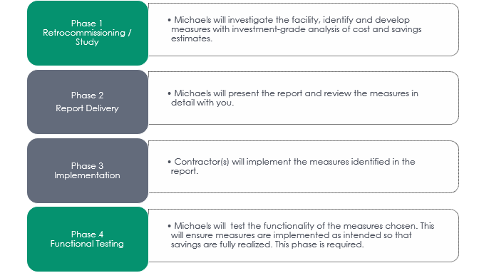

Building Description

Occupancy Patterns

Space Heating
Makeup air and ventilation is provided by the supply fans of two RTUs. Neither RTU is equipped with pre-heating capabilities and they exclusively provide the proper amount of air required by the space, as well as outdoor air to meet the ventilation requirements. Primary heating is provided by electric resistance reheat coils in each of the perimeter variable air volume (VAV) boxes located in ceiling spaces throughout the building. Boxes with electric reheats are also equipped with parallel fans that allow the VAV box to pull air from the space and reheat it without having to go through the RTUs. This is especially important at night when the RTUs shut off and the VAVs continue to maintain unoccupied temperature setpoints. The building is equipped with a total of 131 VAV boxes. Two types of VAV boxes are present in the building: the type with reheats are positioned on the perimeter, and cooling-only boxes are positioned in the interior core spaces. It is not known what the count is of each type of VAV box, but a standard distribution for similar buildings is 50-60% of the boxes being equipped with electric resistance heating.

Cooling
Cooling is provided by scroll compressors in the two identical rooftop units (RTUs). RTU 1 serves the north side of the building while RTU 2 serves the south side of the building. Each RTU has four compressors with a total cooling capacity of 90 tons. Each RTU utilizes standard efficiency direct expansion (DX) cooling which corresponds to an 11.0 IEER and 9.5 EER rating according to IECC 2015. Each RTU has a discharge air temperature setpoint of 59°F.

Air Handling Equipment
Two identical RTUs provide conditioned air to the whole building. Each RTU has (2) 25-hp supply fan motors and a 30-hp return fan motor. Variable frequency drives (VFDs) modulate the speed of the supply and return fan motors, which in turn modulates the amount of air being provided by the fans. Each RTU is scheduled to operate from 6 AM to 6 PM on weekdays through programmable thermostats located in a mechanical room on the fourth floor. While in unoccupied mode, the RTUs shut off completely, providing no air to the building at that time.

Temperature Controls
Temperature is controlled by pneumatic thermostats located throughout the facility. Each pneumatic thermostat is tied to an individual VAV box and will call for heating or cooling based on the space temperature setpoint. Each tenant has control of the thermostats located in their space and can adjust them as they wish.

Humidity Controls
The zone thermostats do not have the capability to control or monitor space humidity. Air is dehumidified by the cooling coils in the RTUs. There is no means of adding humidity to the air during periods of low relative humidity.

Building Pressure Control
The building maintains a static pressure of 0.05 in W.C. by varying VAV box damper positions and exhaust fan speed.

Domestic Hot Water
Domestic hot water is supplied by two electric hot water heaters. The larger unit on the second floor is an 80-gallon tank, and the smaller unit located in the ceiling is a 20-gallon tank. The larger hot water heater is equipped with a 1/8-hp circulation pump that operates continuously to supply hot water through the piping system. This, in turn, ensures that hot water is ready and available at each faucet throughout the building as soon as the faucet is turned on.

Lighting
The fourth-floor restrooms, suites 360 and 350, are equipped with 32-watt, 4-ft T8 lamps. The mechanical rooms are equipped with 34-watt, 4-ft T12 lamps. The rest of the lighting in the facility has been upgraded to LEDs. Control of the lighting in the building is split between occupancy sensors and manual switches.
Exterior lighting has been entirely converted to LEDs and is operated based on a timer.

Compressed Air
A large, approximately 100-gallon air compressor is located in the first-floor mechanical room. The compressor is equipped with (2) 5-hp motors that alternate operation to maintain a tank pressure of 20 psi. The air from the compressor is then piped through the building and operates the dampers of each VAV box in the building, as well as the pneumatic thermostats.
Additional System details are provided in the appendices.

Building Energy Use and Fuel Cost Information

Building Energy Use and Fuel Cost Information
Table 3 documents current facility energy use and cost. It includes the following:
- Energy use and cost for a recent 12-month period.
- Average unit cost for each type of energy consumed. The average fuel cost is used in the analysis of EMIs unless marginal fuel rates apply. For marginal fuel rates, savings are “taken off the top” first to provide accurate dollar savings.
- Fuel cost and energy intensity for each fuel type.
Table 3. Electric Energy Use and Cost

Historical Energy Use
The facility’s historical energy use profiles below are used to determine general trends in energy consumption.
Figure 1. Annual Electric Use Profile
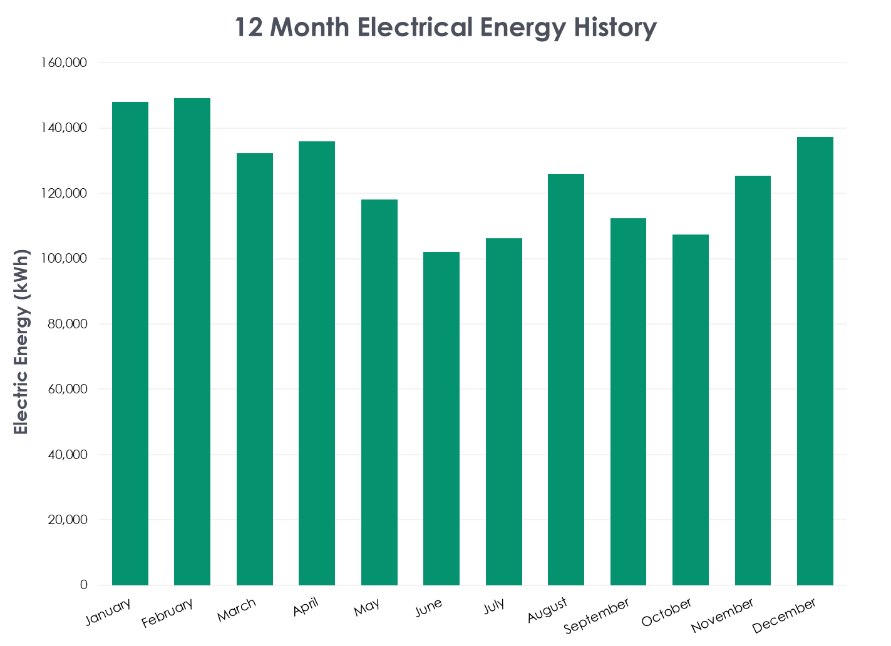
Figure 2. Annual Electric Demand Profile
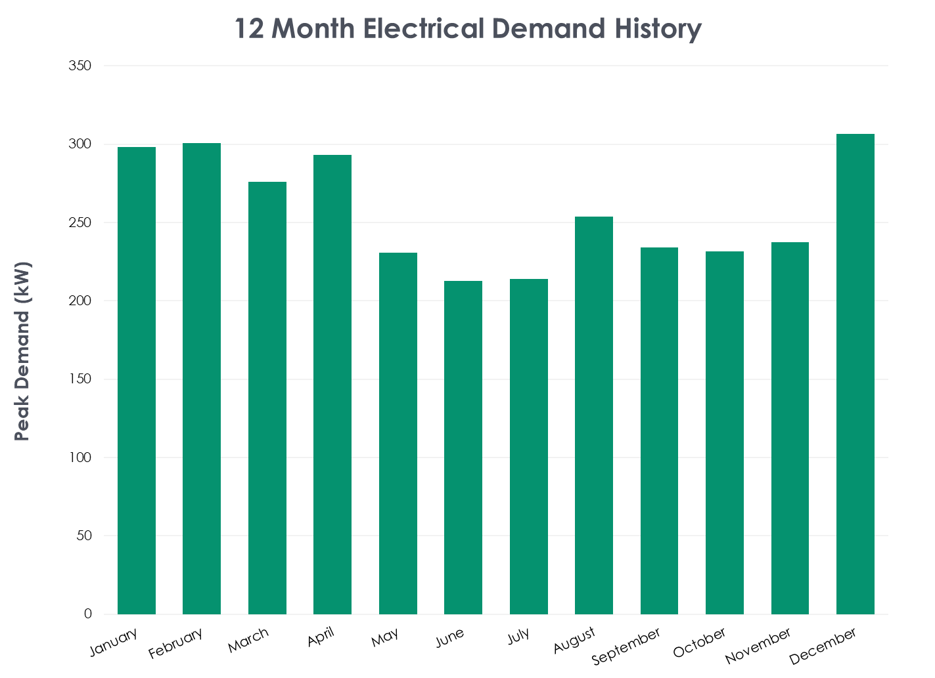

End Use of Energy
The estimated End Use of Energy by major energy using system is presented in Table 4 and Figure 3. This information is used in determining the areas of primary emphasis for energy conservation activities, and in estimating the savings from the implementation of building and system modifications.
Table 4. End Use of Electricity

Figure 3. Electrical End Use
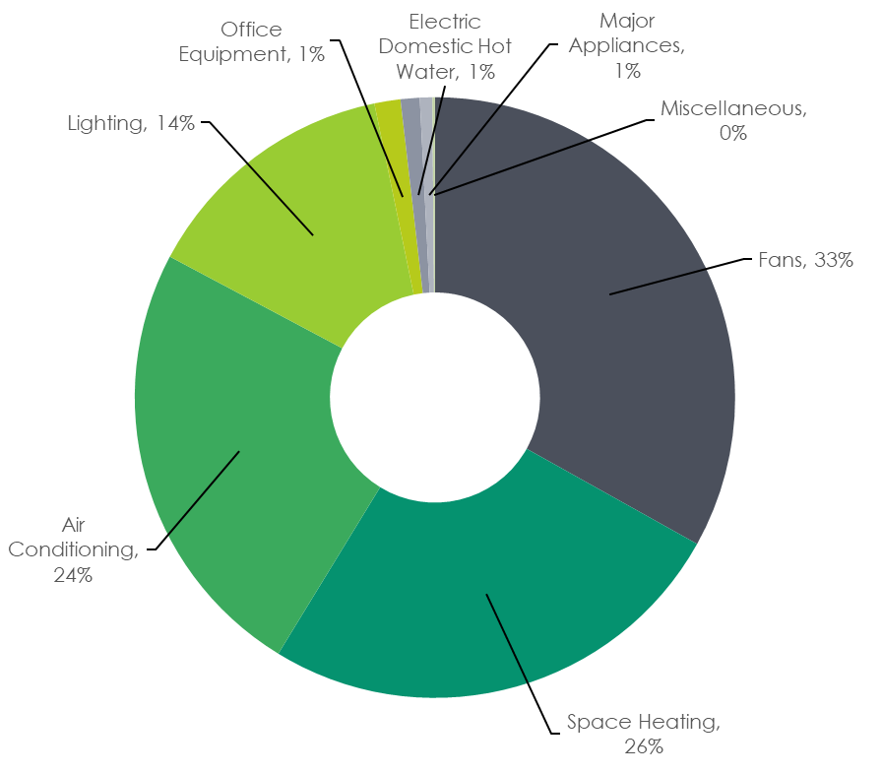

Analysis Methods

Estimating Methodologies
The implementation cost and energy saving estimates are based on information gathered from available plans, observations during the on-site visit and information provided by building operators. Opinions of probable construction cost and energy savings were made based on Michaels Energy’s experience and qualifications and represent our best judgment as experienced and qualified design professionals.
Energy savings consider the interactions that exist between items. Energy management improvements are assumed to be implemented in order unless otherwise noted.
When applicable, marginal fuel rates are used. Savings are “taken off the top” to provide accurate dollar savings estimates. The last energy purchased is subtracted first. When applicable, seasonal, on and off peak, and demand rates are used with an estimated savings allocation to each. For other tariffs the recent twelve-month average fuel costs are used each fuel type. Fuel costs do not include fixed monthly charges such as a monthly customer charge. Taxes, if applicable, are included in the rates.
Material Costs are based on either recent vendor quotes for similar products or values listed in standard estimating guides and product catalogs.
Labor Costs are based on prevailing wage rates for local contractors. Wage rates for self-installed projects (if applicable) were provided by the customer or the labor was a sunk cost and therefore, not included.
Design cost estimates should be considered preliminary. The actual cost may vary depending on the total size of the implementation project and the specific scope of services desired. In some cases, projects are broken into small segments to illustrate the economic feasibility of certain specific technologies or portions of a broader technology classification. It should be noted that implementing only small portions of a larger energy efficiency project will increase cost for those small portions, possibly by a substantial amount.
Michaels Energy does not have control over the operation of the building, the cost of labor, material, equipment, or services furnished by others. Accordingly, Michaels Energy does not guarantee that energy savings, proposals, bids or actual costs will not vary from those contained in this report.

Economic Analysis Methods
Three indicators are used to present the economic attractiveness of each EMI:
Simple Payback Period is equal to the initial cost divided by the estimated annual savings. The simple payback period is the approximate time required to recoup the initial investment.
Net Present Value is equal to the present value of all future savings over the useful life of the modification minus the initial investment. In many cases, only incremental first cost is used. In this case, the first cost of the base project is $0. If maintenance costs are estimated to be similar for all options, they are excluded from the analysis. Future costs are adjusted for escalation and time value of money. An EMI is cost effective if the Life Cycle Savings is greater than zero. In the case of mutually exclusive EMIs, assuming analysis periods are equal, the option with the greater Life Cycle Savings is the most cost effective.
Savings to Investment Ratio compares the lifetime savings of a project to the initial investment. This ratio is used to compare several projects, and the project with the higher value will have the higher return per dollar invested.
Adjusted Internal Rate of Return is a form of internal rate of return that assumes all returns are reinvested at a company’s cost of capital. It compares profitability and measures the net present value of future cash flows.
- The general inflation rate, discount rate and energy cost escalation factors used are taken from Energy Price Indices and Discount Factors for Life-Cycle Cost Analysis – 2015, Department of Energy, 2015.
- A discount rate of 3.0% is used to discount future cash flows to the present. The real discount rate and all other costs exclude general inflation. The analysis results would be the same if general inflation were included in everything.

Energy Management Improvements (EMIs)
The primary objective of this project is the identification and analysis of EMIs. This section documents the criteria used in the analysis and provides a detailed description and cost for each EMI studied.
Each EMI includes a description of the existing system, piece of equipment or operating procedure followed by a detailed description of the proposed retrofit, replacement, installation, or operating procedure.
The financial analysis of all EMIs includes both life cycle savings and simple payback. Each EMI was studied to determine its technical feasibility and to estimate its initial cost and effect on long-term maintenance, operating and energy costs. The recommendations conform to local and state building codes.
Applicable Rebates:
Rebates are evaluated on a custom basis once the P4P Threshold has been met. Exact numbers are not available at this time, but can be provided by the Colorado Springs Utilities Account Manager.

EMI 1 – Install New Building Automation System
Current Conditions:
Currently, controls of the HVAC of the building are done through many different systems that must be changed and updated independently of each other. Three key types of equipment are utilized in the current system to operate the HVAC: pneumatic thermostats, programmable thermostats, and onboard RTU controls.
Pneumatic Thermostats
Temperature controls are all done through pneumatic thermostats that are located inside the tenant spaces that each VAV box serves. Tenants have full access to the thermostats and can change the temperature setpoint of the space at will.
Programmable Thermostats
Scheduling of the rooftop units (RTUs) is done through two programmable thermostats, one for each RTU, in a fourth-floor mechanical room. Both RTUs are scheduled to operate from 6AM to 6PM and are completely shut off when in unoccupied mode.
Onboard RTU Controls
Economization is programmed and controlled through each RTU’s onboard programming and has a temperature range of 40°F to 75°F. Discharge air temperature (DAT) is also controlled through the onboard controls of the RTUs. Currently, DAT is set to 55°F in the cooling season and 70 °F in the heating season. The changeover between season must be done manually by the building engineer by visiting each RTU on the roof and making the update. Finally, static pressure is controlled by the onboard controls of the RTUs. Each RTU is programmed to maintain a duct static pressure of 1.5 in. WC. and a building pressure of 0.05 in. WC.
Proposed Changes:
Install a building automation system (BAS) with the capability to monitor and control space temperature setpoints, building schedule, economization, DAT, and static pressure, which are currently being controlled by independent systems. Ensure trending of key data points is set up and monitored to ensure smooth operation and rapid detection of deviations as well as remote access to the BAS for the facilities team to monitor operation of the building while not on site. It is also recommended to inquire about the ability to add price signaling from Colorado Springs Utilities.
Energy Savings:
This measure does not have direct energy savings associated with it. Instead, this measure enables the entire suite of measures that are listed below in EMI 1.1-1.5. The added visibility into how the building is operating allows the building engineer to quickly understand and address any changes to the building’s HVAC system. As an example, in the current system, a stuck damper on a VAV box could go years without being found unless the tenant contacts the facilities team with a complaint. With most building automation systems, VAV box airflow is tracked, and a quick trend can show the building engineer that the damper is not modulating as it should.
There are advantages to installing a new BAS that go beyond energy savings. One of the major non-energy benefits is in operations and maintenance. Discharge air temperature can be programmed to change automatically rather than manually; this will be discussed more in EMI 1.2. Tenant comfort will likely also be improved with the automation of discharge air temperature. Colorado experiences many days where heating is required in the early morning, while cooling is needed in the afternoon. If the discharge air temperature is not being updated multiple times a day during these periods, the building will either be experiencing inefficiency with overcooling the air in the morning or tenant discomfort by not providing sufficient cooling in the afternoon. Beyond O&M and tenant comfort, other non-energy benefits may include improved operability, enhanced energy management best practices, prolonged equipment life, and improved indoor air quality (IAQ). These alternative benefits are not discussed in detail, but should be acknowledged when considering implementation of this EMI.

Figure 5. RTU Onboard Controls
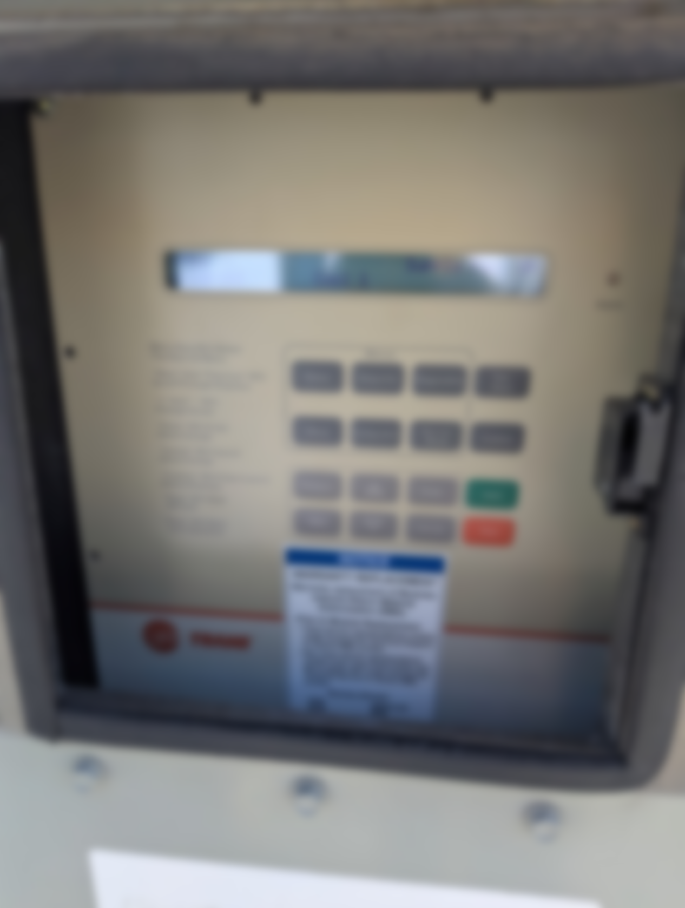

EMI 1.1 – Implement Static Pressure Reset
Current Condition:
The RTUs are programmed with a static pressure setpoint of 1.5 in. WC. This is a limitation of utilizing the onboard controls of the RTUs as well as not having full integration of the systems in the building. The RTUs currently must maintain the same static pressure to ensure all the spaces receive enough air to achieve space temperature setpoints and proper indoor air quality.
Proposed Modification:
Implement a static pressure reset strategy for all RTUs that allows each unit’s static pressure setpoint to vary from its current setpoint down to a value of 0.5 in. W.C. less than the maximum. In times of low load, the VAV boxes close to a lower percentage, allowing less airflow from the supply fans. It is recommended to implement a trim-and-respond control sequence consistent with ASHRAE Guideline 36 that also ignores the first two or three VAV box requests for more airflow to prevent rogue zones from overriding the reset.
Energy Savings:
Energy savings are expected from reducing average supply fan speed during periods of lower airflow demand, particularly during shoulder seasons when loads are reduced. Lowering the static pressure setpoint decreases fan brake horsepower while still maintaining required airflow to the zones. The savings shown above are driven by reduced fan energy consumption while maintaining proper system performance.

EMI 1.2 – Implement Discharge Air Temperature Reset
Current Condition:
The AHUs maintain a fixed supply air temperature of 55°F during cooling season and 70°F during heating season. During periods of low cooling demand, the VAV boxes close to their minimum position to avoid over-cooling the space. If the space is still being over-cooled, the electric resistance reheat coils in the perimeter boxes reheat the supply air.
Proposed Modification:
It is recommended to automate the discharge air temperature so the building engineer does not need to manually change the values on the RTUs. Beyond the automation, it is recommended to reset the supply air temperature from 55°F up to 65°F based on zone cooling demands. ASHRAE 36 has guidelines for implementing a trim-and-respond sequence that allows for maximum savings while maintaining tenant comfort.
Energy Savings:
Savings will result from the reduced need to reheat supply air at the VAV boxes. Some savings will be seen from a reduced cooling load in the shoulder months as a higher temperature is maintained.
Non-energy benefits include decreased operations and maintenance costs, as the building engineer will no longer need to manually make changes at the RTU control panels, as well as potential for increased tenant comfort on days with large temperature swings.

EMI 1.3 – Standardize Space Temp Setpoints
Current Conditions:
Temperature controls are all done through pneumatic thermostats that are located inside the tenant spaces that each VAV box is serving. Tenants have full access to the thermostats and can change the temperature setpoint of the space at will. Typically, when given full access to temperature controls along with being dissociated with the energy bills, people will tend to set the temperature on the thermostat too high in the winter and too low in summer, causing excess energy use.
Proposed Changes:
Control temperature setpoint in the BAS rather than through individual pneumatic thermostats. Typically, this is implemented in one of two different ways and is usually predicated on the relationship with the tenant. The most common approach is to exclusively control temperature setpoints in the BAS. In this case, separate heating and cooling setpoints are programmed in the BAS and are typically programmed with a two-degree deadband between the two setpoints. Some tenants feel the need to have control over the temperature in the space and, given that the tenants currently have full control right now, may be likely in this building. In these cases, a setpoint can be programmed in the BAS, and the tenants can be given a limited range of control through a local thermostat. These thermostats are allowed to have the temperature of the space increased or decreased two or three degrees from the general setpoint.
Energy Savings:
The energy savings of this measure comes from maintaining a more moderate temperature in the building. This, in turn, reduces the temperature difference between the interior of the building and the outdoor air. The reduced temperature difference in turn reduces the heat lost in the winter and the heat gained in the summer, which lowers the cooling and heating demands.
This update will also eliminate the potential for simultaneous heating and cooling in a space. When VAV boxes serving spaces close together are set to significantly different temperature setpoints they will begin to fight each other to try and maintain the two different setpoints.

EMI 1.4 – Implement Nighttime Heating Setback
Current Conditions:
Currently, the pneumatic thermostats set and maintain one specific temperature. The RTUs are scheduled to be turned off from 6PM to 6AM on weekdays and on the weekends. While the RTUs are set to unoccupied, the parallel fan power boxes will maintain air circulation and the electric heating elements in the boxes will continue to provide heating to the space.
Proposed Changes:
Implement a setback schedule for heating that is in line with the current RTU schedule. Calculations assume an occupied heating temperature of 70°F and an unoccupied temperature setpoint of 60°F.
Energy Savings:
The energy savings of this measure come from reducing the amount of heat lost from the building while it is unoccupied by reducing the temperature differential between interior and exterior temperatures. Along with the savings from reduced heating loads, the fans in the fan-powered boxes will be required to run less hours which will also result in significant energy savings.

EMI 1.5 – Schedule Exhaust Fans
Current Conditions:
Currently, the two exhaust fans serving restrooms and electrical closets operate continuously. The RTUs serving the buildings are scheduled by the programmable thermostats to operate from 6 AM. to 6 PM, Monday - Friday.
Proposed Changes:
Operate the exhaust fans on the same schedule as the RTUs. The exhaust fans are not currently monitored or scheduled. Implementation of this measure hinges on adding the ability to schedule the exhaust fans on the BAS.
Energy Savings:
Currently, the exhaust fans draw warm air into the building via infiltration during unoccupied hours when the outdoor air temperature is above the space cooling setpoint. The RTUs must compensate for these thermal gains at the beginning of the period of occupancy. Additionally, the exhaust fans draw cold air into the building during unoccupied hours when the outdoor air temperature is below the heating balance point. The electric reheat coils in the VAV boxes must compensate for these thermal losses throughout the unoccupied period to maintain the occupied heating setpoint. Scheduling the exhaust fan will reduce the amount of energy used by the exhaust fan, as well as the energy required to overcome the thermal gains and losses associated with drawing unconditioned air into the building during unoccupied hours.

EMI 1.6 – Replace Pneumatic Controls with Direct Digital Control
Current Conditions:
Currently, all the VAV boxes are controlled with pneumatic actuators that control damper position and turn on and off the heating elements. All the thermostats in the tenant spaces are also utilizing pneumatic controls to detect and communicate the temperature setpoints.
Proposed Changes:
Replace the pneumatic controls with direct digital controls (DDC) and eliminate the air compressor in the main floor mechanical room. Each VAV box should be retrofitted with DDC controls to modulate damper positions and enable/disable electric heating. Each thermostat should also be retrofitted to a digital thermostat capable of being programmed.
Energy Savings:
The energy savings from this measure result from eliminating the need for the compressor that is used to operate all the pneumatic controls in the building. Beyond the energy savings, this measure eliminates some risk associated with the building. Pneumatic controls are an antiquated technology that are highly prone to failure, especially as the system gets older. The rubber tubing that connects each component to the compressed air is prone to cracking, and any downtime of the main compressor results in complete loss of control over the building’s HVAC.
On top of the risk for loss of control, the number of technicians knowledgeable in the technology is also diminishing. This means that as time goes on, the current system will become harder and more expensive to service.
This measure is connected to the implementation of the BAS. While this measure does not require the implementation of the BAS like the EMIs before this one, it is highly recommended that they be done at the same time. A new BAS will require a way to communicate with all the VAV boxes and thermostats. A complete replacement of the controls is recommended over any other solution due to the reasoning above.
Figure 7. Air Compressor for Pneumatic Controls
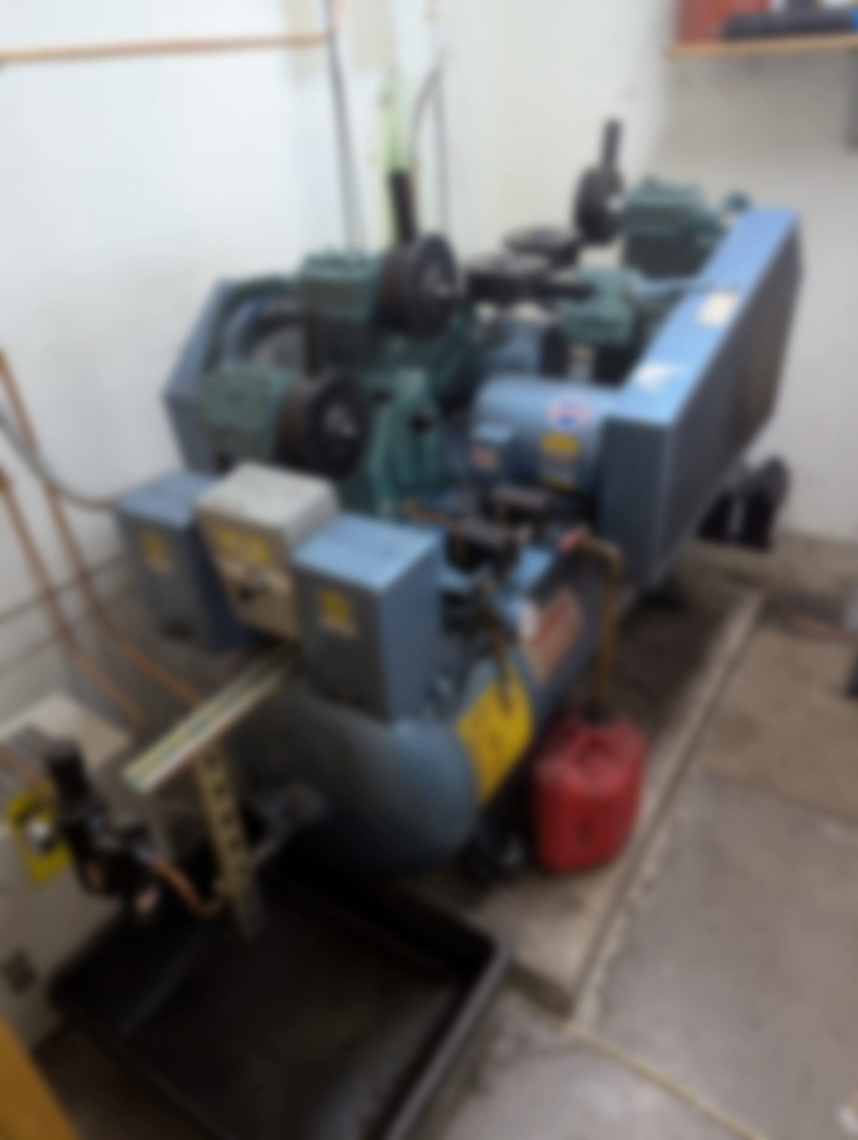

EMI 2 – Replace Remaining Fluorescent Fixtures with LEDs
Current Conditions:
Currently, the fourth-floor restrooms, suites 360 and 350, are equipped with 32-watt, 4-ft T8 lamps. The mechanical rooms are equipped with 34-watt, 4-ft T12 lamps.
Proposed Changes:
It is recommended that all fixtures be converted to LEDs, which use a fraction of the energy of the fluorescent lamps currently in place and have a significantly longer lifetime.
Energy Savings:
This measure saves energy due to the much lower power draw offered by the LED fixtures for the same light output. The office lighting currently uses approximately 56W per fixture while the new LEDs are expected to use 20W to achieve the same lumen levels; 1/3 the energy usage. Lighting is an excellent opportunity to save because it does not depend on the weather and is a necessary part of every building.
Figure 8. Existing Fluorescent Lighting


EMI 3 – Schedule Hot Water Pump
Current Conditions:
The domestic hot water is provided by an electric resistance storage water heater in the mechanical room. This single source of domestic hot water uses a 1/8-HP circulation pump to ensure that water at the tap becomes hot in a reasonable timeframe. This pump operates continuously.
Proposed Changes:
Install a timer on the circulation pump so it can be turned off during unoccupied periods. It is assumed that this circulation pump can operate on the same schedule as the building and associated HVAC equipment. It should be noted that the circulation pump being off does not mean that hot water is completely inaccessible during unoccupied times. The hot water heater will maintain the temperature in the tank, but all the water in the piping around the building will be stationary and cool down to room temperature. Much like hot water in a house, hot water can be provided to sinks around the facility without the circulation pump, but the tap will need to run longer; therefore, it is only recommended to turn off the pump when the chance of hot water being needed is low.
Energy Savings:
Energy savings will result from decreased heat loss in the hot water piping and decreased pump operation. Having hot water in the piping system means that there is a much larger surface area for heat transfer to occur, which adds to the effective volume of water that the water heater must serve. Not running the circulation pump when the building is unoccupied reduces the amount of heat lost to the environment and lowers the effective volume of water being served.
Figure 9. Hot Water Pump
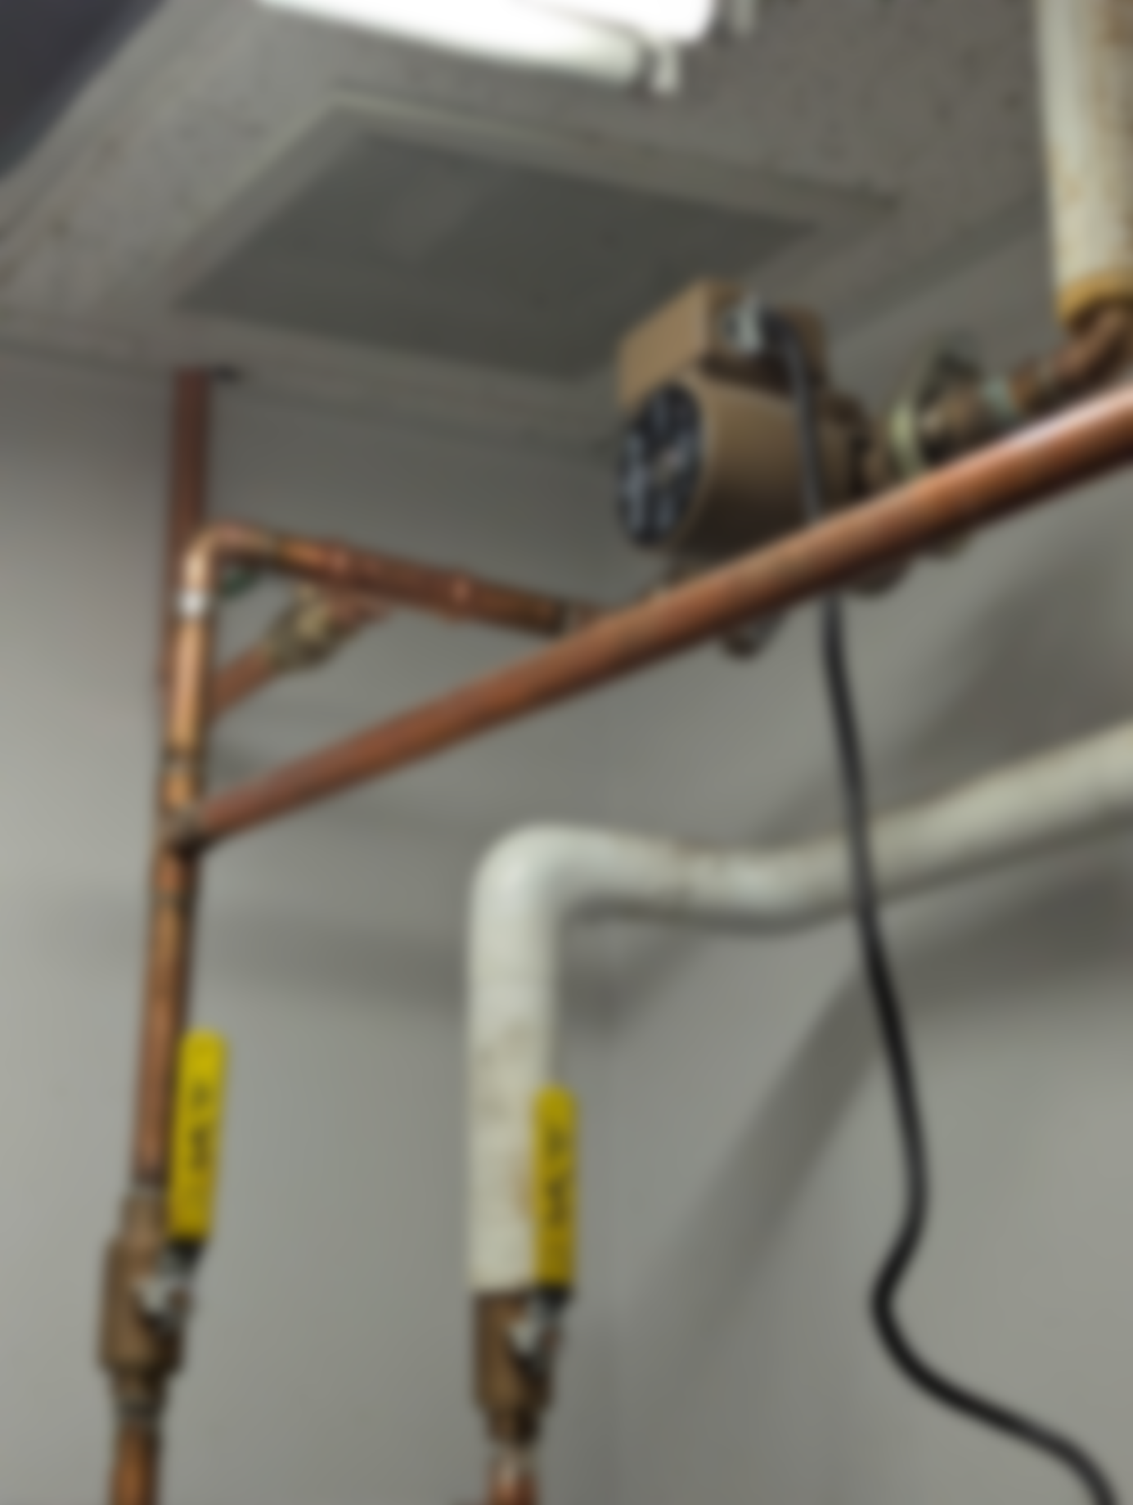

EMI 4 – Install Evaporative Precooling
Current Conditions:
Currently, all cooling for the facility is done with the compressors in each of the two RTUs. Each of the RTUs have four scroll compressors that mechanically cool the incoming air through a process known as direct expansion (DX) down to the discharge air temperature setpoint. This process is effective at achieving the cooling needed for the building but is quite energy-intensive.
Proposed Changes:
Install evaporative precoolers on the two main RTUs. An evaporative precooler goes in the path of the air stream before the compressors in an RTU and is comprised of a membrane that is kept wet while the RTU is in operation. Air passing through the membrane absorbs the water, which naturally cools the air through a process called adiabatic cooling by increasing the relative humidity.
Energy Savings:
Evaporative cooling is a passive process, meaning that no energy needs to be consumed to achieve the cooling beyond what is already being used to move the air. Direct expansion cooling on the other hand is an active process which requires constant energy to achieve cooling. This means that any reduction in temperature that is achieved from the evaporative precooling takes close to zero energy to achieve and removes that load from the scroll compressors. This measure is particularly effective in Colorado where the relative humidity is quite low, which allows for a significant amount of water to be added to the air.
This measure does consume water, while traditional DX cooling does not. The cost of the water consumed is more than offset by the energy savings from the cooling.

EMI 5 – Install Heat Pump Water Heater
Current Conditions:
Currently, domestic hot water is supplied by two electric hot water heaters. The larger unit on the second floor is an 80-gallon tank, and the smaller unit located in the ceiling is a 20-gallon tank. Heating in the large water heater is achieved through a 4,500W electric resistance heating element.
Proposed Changes:
Replace the larger water heater with an equivalent-sized heat pump water heater. Heat pump water heaters require a sufficient air volume in the space they are in because they exchange heat with the surrounding air. Adding a louver to the door of the mechanical room may be required to satisfy the air requirements.
Energy Savings:
The current electric resistance water heaters have an efficiency limit of 100%. Every BTU of energy that is currently being provided to the heating element is making its way to the water in the form of thermal energy. Heat pump water heaters utilize a reversing valve to exchange heat with the surrounding air, which allows them to achieve efficiencies in the realm of 250%. This increased efficiency is the main source of energy savings.
Some small interactive effects will also be present with this upgrade. Because the heat pump water heater exchanges heat with the surrounding air there will also be a small cooling effect to the area. This may result in slight cooling savings and heating penalties; however, these effects will typically offset each other in the long run.
Figure 10. Main Hot Water Heater
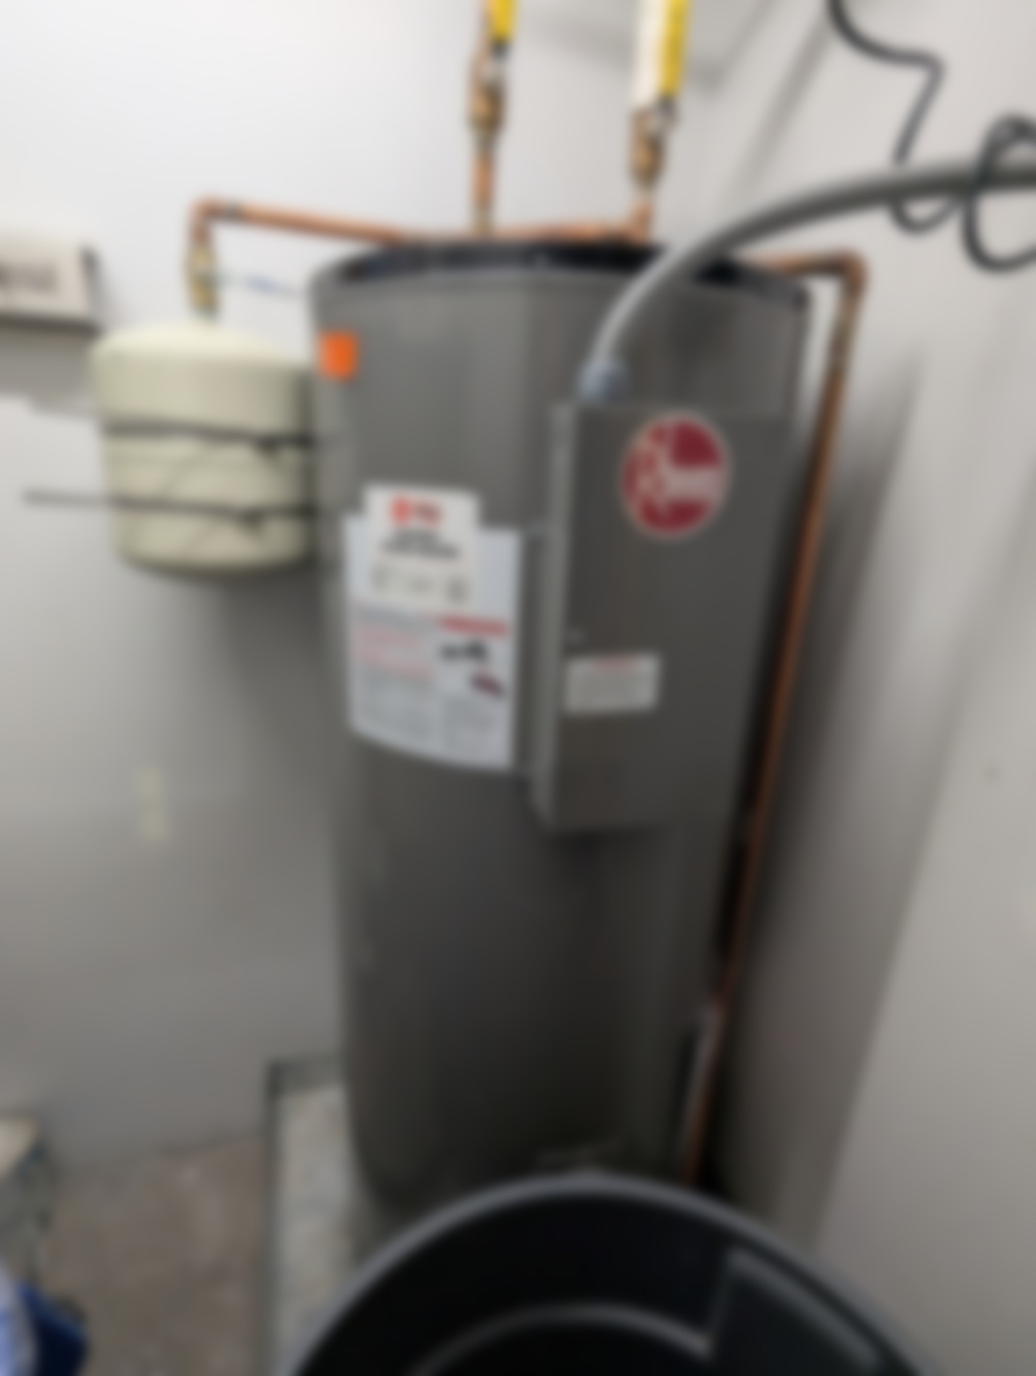

EMI 6 – Install Heat Pump RTUs
Current Conditions:
Currently, all cooling for the facility is done with the compressors in each of the two RTUs. Each of the RTUs have four scroll compressors that mechanically cool the incoming air through a process known as direct expansion (DX) down to the discharge air temperature setpoint. This process is effective at achieving the cooling needed for the building but is quite energy-intensive.
Primary heating is provided by electric resistance reheat coils in each of the perimeter variable air volume (VAV) boxes located in ceiling spaces throughout the building. Boxes with electric reheats are also equipped with parallel fans that allow the VAV box to pull air from the space and reheat it without having to go through the RTUs.
Proposed Changes:
Install heat pump RTUs in place of the current DX RTUs. Heat pump RTUs can provide both heating and cooling and will therefore add efficiency to all aspects of the building’s HVAC. One current limitation of heat pumps is their sizing, and the largest commercially available unit is 60 tons. The calculation assumes that two 45-ton heat pumps will be installed in place of each 90-ton RTU. Each heat pump has a minimum outdoor air temperature at which it can operate, and any temperatures below that must be compensated for by a backup heat source. The calculations for this measure utilize a standard heat pump which have a typical minimum operating temperature of 30°F. Below 30°F the electric heating elements from the fan-powered boxes will continue to be the primary heating source.
Energy Savings:
The energy savings of this measure come from the increased efficiency of both heating and cooling. A typical heat pump RTU has a cooling efficiency of 18 IEER, which compared to the code minimum efficiency for a DX unit of 11.7 IEER, is a significant upgrade in efficiency. As with the water heaters discussed above, a heat pump RTU is also able to achieve heating efficiencies greater than 100%. A typical heat pump RTU can achieve a heating efficiency of about 230% while the current electric resistance heating is limited to an efficiency of 100%.
Depending on the timing of this measure’s implementation and the changes in the technology, additional savings may be achieved from this measure. Cold climate heat pumps are a rapidly evolving technology that allows the heat pump to continue operating at lower outdoor air temperatures, with some being able to operate down to 0°F. It is recommended to investigate the current technology offerings at the time of implementation to see if more savings can be achieved than the standard heat pump calculated here.

Additional Energy Management Improvement Considered
In addition to the projects identified and evaluated in detail above, there is another group of projects that were considered. Although these projects are sometimes cost effective in other facilities, preliminary analysis has shown that they do not yield an equitable payback for this building.

Commission VAV Boxes and Conduct Balancing Report
During initial commissioning of a VAV system, each box is designed and calibrated to provide a specific amount of air during peak loads. Over time, VAV box setpoints are susceptible to drifting off their original design especially in a pneumatic system that does not have any visibility into exact operation. It is recommended to conduct an air balancing report at the time of installing the new BAS. If a full DDC replacement is chosen (EMI 2), then each VAV box will need to be commissioned at the time of the replacement. This will ensure the system has all the proper setpoints at the time of installation and may be more cost effective than trying to commission the boxes and balance the boxes at separate times.
Since the exact drift of each box could not be evaluated during this study, an assumption had to be made on the amount each box has drifted from design. For calculation purposes it was assumed that the average airflow of the system is 10% greater than the initial design.

Building Performance Standard Compliance
There are four different paths to compliance through the Colorado Building Performance Standards Program administered by the Colorado Energy Office (CEO). Below is a brief description of each pathway and its unique characteristics.
Flat Energy Use Intensity (EUI) Point Reduction
This is the stock standard of compliance. The state automatically enrolls buildings into this path if an alternative path is not specified. Each building type has an EUI target specified by the state that can be found in the state’s technical guidance. This path is generally the most beneficial for buildings that have been aggressively pursuing energy efficiency before the 2021 baseline year. EUI is calculated by converting electric and natural gas energy into a common unit of kBtu and dividing it by the total facility square footage.
Percentage Energy Use Intensity (EUI) Reduction
The state has set a percentage reduction target for both 2026 and 2030. The percent reductions are not based on building end use so all buildings using this pathway are targeting a 13% EUI reduction by 2026 and a 30% reduction by 2030. The percentage reduction path is generally the most beneficial for buildings that did not aggressively pursue energy savings prior to 2021. It can also be more beneficial for older buildings that have original equipment that is less efficient.
Flat Greenhouse Gas Intensity (GHGI) Point Reduction
This path shares many similarities to the flat EUI reduction pathway. The state has set targets based on building end use in both 2026 and 2030. This path is generally the most beneficial for buildings that have been aggressively pursuing energy efficiency before the 2021 baseline year.
The key difference between this path and the flat EUI reduction path is the ability to incorporate renewable energy to achieve the goals. This path can take credit for the carbon reduction from renewable energy sources which can be used to bridge any gaps in reaching compliance. GHGI is calculated by utilizing a predetermined emission factor for both electricity and natural gas. These factors were determined based on a state aggregate and are available in the BPS Technical Documents.
Percentage Greenhouse Gas Intensity (GHGI) Reduction
The state has set a percentage reduction target for both 2026 and 2030. The percent reductions are not based on building end use so all buildings using this pathway are targeting a 13% GHGI reduction by 2026 and a 30% reduction by 2030. The percentage reduction path is generally the most beneficial for buildings that did not aggressively pursue energy savings prior to 2021. It can also be more beneficial for older buildings that have original equipment that is less efficient. As with the flat GHGI reduction path credit, carbon reduction from renewable energy can be included in the calculations for this path.
Below you will find a table outlining how your building will be performing on each of the four pathways after implementation of the measures included in this report. It has been assumed that all RCx measures will be implemented prior to 2026, and all capital measures will be implemented prior to 2030.
Table 5. Building Performance Standard Summary Table

Recommendations
The measures in the first group below are recommended for implementation. If [Customer Name] chooses to implement any of the capital investment measures and they want to use any Colorado Springs Utilities incentive programs (i.e. custom rebate), they need to gain pre-approval from Colorado Springs Utilities before any equipment is purchased or installed.
Table 6. Summary Table

Figure 11. Benchmark Results, Peer Comparison, Savings Target, Total Savings
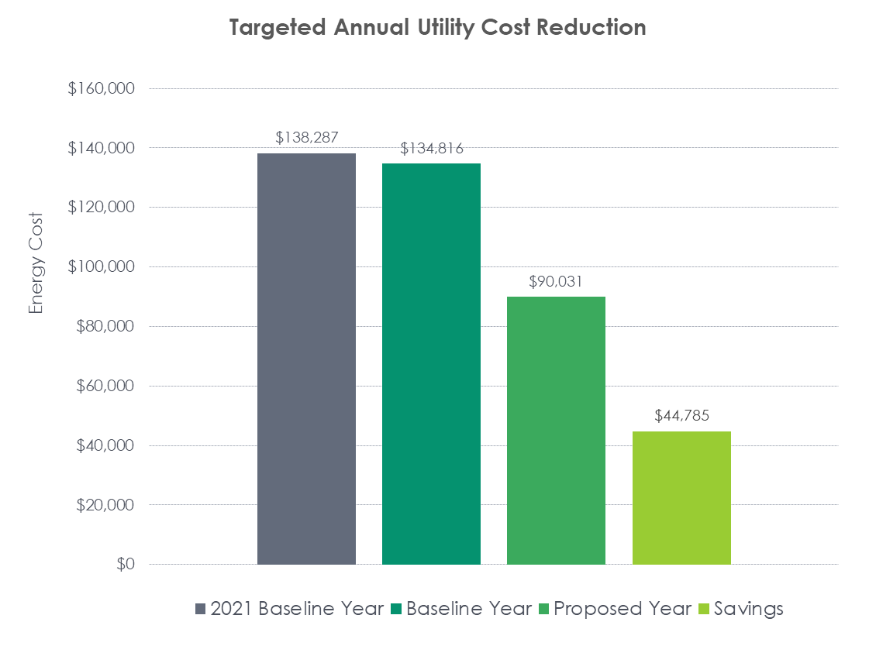

Table 7. Energy Summary Table

Next Steps
The next steps in the RCx process include detailed project development and documentation followed by implementation and real-time verification of installed measures. All projects require preapproval from Colorado Springs Utilities to receive credit for the changes.
Following the preapproval [Customer Name] will work with a controls contractor of their choice to implement the measures. Once all the selected measures have been implemented Michaels Energy will return on site to do functional testing of the equipment to ensure that all the measures are operating as intended. Finally, after the functional testing to confirm implementation, Michaels Energy will perform a bill analysis compared to a predictive model of energy usage to confirm that the energy savings calculated during preapproval is being achieved.
Once the bill analysis is completed and confirming 10% energy savings Colorado Springs Utilities will award the pay for performance rebate.

Appendix A Detailed System Data

Appendix B Cost Data

